Template Design Pattern

GOF: **Define the skeleton of an algorithm in an operation, deferring some steps to subclasses. Template Method lets subclasses redefine certain steps of an algorithm without changing the algorithm's structure.**

**Structure Diagram**

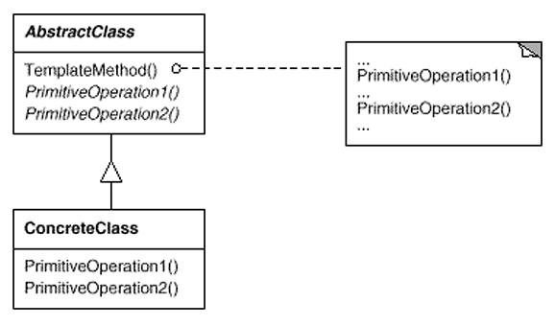

Java Code Example

**public** **class** MonthlyReport **extends** AbstractReport {

@Override

**public** **void** setHeader() {

System.***out***.println("Header set ...");

}

@Override

**public** **void** setBody() {

System.***out***.println("Body set ...");

}

@Override

**public** **void** setFooter() {

System.***out***.println("Footer set ...");

}

}

**public** **abstract** **class** AbstractReport {

**public** **abstract** **void** setHeader();

**public** **abstract** **void** setBody();

**public** **abstract** **void** setFooter();

**public** **void** generateReport() {

setHeader();

setBody();

setFooter();

}

}

Class Diagram

**public** **class** Test {

**public** **static** **void** main(String[] args) {

AbstractReport report = **new** MonthlyReport();

report.generateReport();

}

}

